Normalization

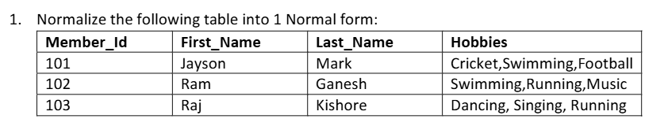

Solution :-
Member_Id | First_Name | Last_Name | Hobby
101 | Jayson | Mark | Cricket
101 | Jayson | Mark | Swimming
101 | Jayson | Mark | Football
102 | Ram | Ganesh | Swimming
102 | Ram | Ganesh | Running
102 | Ram | Ganesh | Music
103 | Raj | Kishore | Dancing
103 | Raj | Kishore | Singing
103 | Raj | Kishore | Running

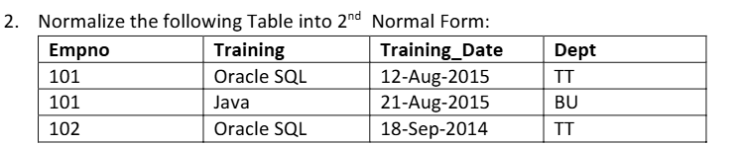
103
*Note - The second record has been assumed to be Empno = 103 instead of 101, as an employee cannot belong to two different departments in a valid 2NF example.

Soultion :-
Employee Table:
Empno | Dept
101 | TT
103 | BU
102 | TT

Training Table:
Empno | Training | Training_Date
101 | Oracle SQL | 12-Aug-2015
103 | Java | 21-Aug-2015
102 | Oracle SQL | 18-Sep-2014

3. Normalize the following into 3rd Normal Form:
Member_Id | First_Name | Last_Name | Sports | Fees
101 | Rajesh | Chand | Cricket | 100
102 | Jayesh | Raj | Hockey | 80
103 | Mark | Dorson | Football | 90

Solution :-
Member Table:
Member_Id | First_Name | Last_Name | Sports
101 | Rajesh | Chand | Cricket
102 | Jayesh | Raj | Hockey
103 | Mark | Dorson | Football

Sports_Fees Table:
Sports | Fees
Cricket | 100
Hockey | 80
Football | 90

